**Team dynamics:** We are 3 students in our team and our whole work we divided into 3 parts

1. Design part
2. Theme development part
3. Theme development part

I did the design part.

The design process includes:

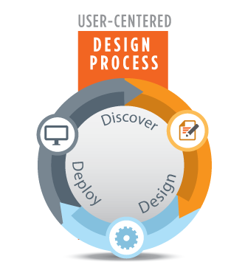

* Prototyping
* Functional Design
* Technical Design
* System Architecture
* Training Plan
* Test Plan
* Discover
* Deploy